Why Progamming?
- Because we humans have lot of languages to communicate.
- But, we can’t communicate with machines in human languages.
- So we need a language to communicate with machines ie machine understandable language to develop applications to perform our required actions.
- That’s the reason we need programming.
How many types of programming languages are there?
- Low Level Language.
- High Level Language.
- Middle Level Language.

- We generally write a program using high – level language. Ie, English
- This high level language is understandable by humans. It is called Source Code.
- Low level Language is understandable by machines only .
- It consists of 1’s and 0’s.

- To convert source code into machine understandable code ie low level language. We use Compiler o Interpreter.

What is Compiler?
- Compiler complies the source code in one run.
- Error will be shown only after the compilation of whole program.
What is Interpreter?
- Interpreter compiles the source code line by line.
- Errors will be shown for the line if the line fails before whole program.

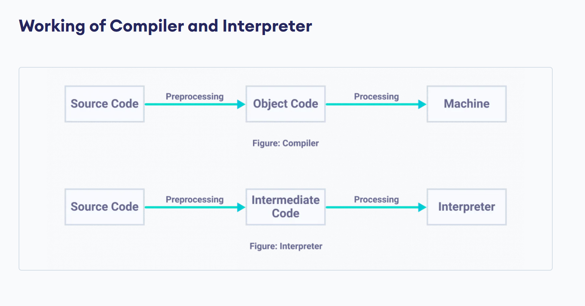
What are the top Programming Languages?
- C++, Python, Ruby , Go Lang , Java script
- We have many Programming Languages. But why Java.

Advantages of Java
- Main Advantage of JAVA

Backward Compatibility
- Backward compatibility means supporting the previous versions of Java along with new version updates.

Features of JAVA
- Platform Independent
- Java is very well known for its platform depenedent feature.
- Java program converts its source code to byte code.
- This byte code can compile on any platform (or Operating System) like Windows ,Linux, MacOS.
- So Java is said to be WORA ie Write Once Run Anywhere.

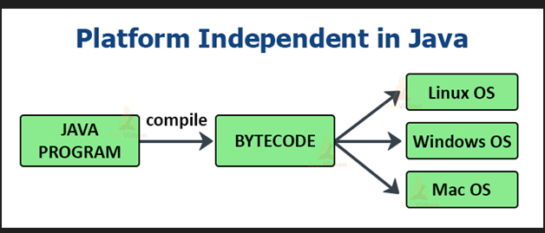

- Object Oriented
- Java strongly supports concepts of Object Oriented concepts.
- Will discuss in detail in coming sessions.

3. Strongly Typed Language
- Java is strongly typed language because it asks for variable declaration of every variable for its data type.
- These data types have specific ranges and users cant create a variable without the range.
- So Java is considered as Strongly Typed Language.
4. Automatic Memory Management
- Java uses an Automatic Memory Management system called Garbage Collector.
- This Garbage Automatically deleted the variables memory after the variable utilization ends.

- Multi Threaded
- Java supports multi threading feature due to this feature tasks which are in the same source code but independent on each other compiles simultaneously.
- So that time taken for compilation of the source code will be minimized.
- Will discuss in detailed way in coming sessions.

